**BEFORE APPLYING K FOLD AND GRID SEARCH:**

DECISION TREE:





LOGISTIC REGRESSION:

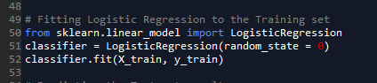

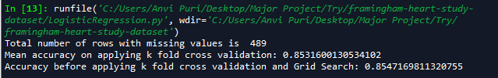

KERNEL SVM

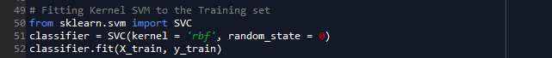

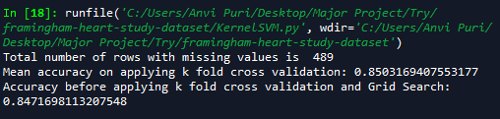

KNN

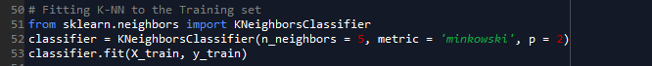

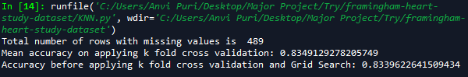

RANDOM FOREST



